**Title for Your Submission**

Full name author A1, Full name author B1*, Full name Author C2

1Affiliation with full address, Including the name of the faculty or department, the name of the institution, the address of the institution, and the postcode.

2Example: The Faculty of Health and Life Sciences, INTI International University, Persiaran Perdana BBN, Putra Nilai, 71800 Nilai, Negeri Sembilan, Malaysia.

**\***Email: Email of the corresponding author(s)

**Abstract**

Abstract should be concise, and should include Problem statement, objectives, methodology, results and discussion, and summary for research paper. The novelty or new findings of the research should be highlighted as well.

**Keywords**

Keyword 1, Keyword 2, Keyword 3, with not more than five keywords

**Introduction**

The submission to INTI Journal has to be written in English, and has to be prepared in Microsoft Word document. The first paragraph of a section should start with the indent shown in this paragraph. The text should be typed in Times New Roman 12 points. The section head should be typed in **Bold**. The second paragraph in each section should start with an indent shown in the next paragraph. Please use APA format for all citations and references.

The content of a research paper is encouraged to be concise and keep within 5 pages excluding references. For research papers, the main content must include title, abstract, introduction, methodology, results and discussion, and conclusion (IMRAD). The paper which does not follow the format will be rejected.

The content of a review paper is limited to 10 pages, excluding references. The main content of the review paper must have an introduction and ends with a conclusion/summary. The content of the paper must adhere to the topic of discussion.

Citations and References should be stated in APA format. For the first appearance, it can be stated as Chong et al. (2018). Chong et al. (2018) should be used after the first appearance of the citation. Two or more citations can be stated as (Teo & Wong, 2014; Wong et al., 2013). The examples for the references are provided in the reference section.

The introduction should content the problem statement and the objectives of preparing the paper. A sub-section for introduction should be avoided.

**Methodology**

**General information on methodology**

Methodology should be written systematically. Only one level of subsection is allowed for methodology as shown in this section. Results or discussion should not be stated in this section. The model of the equipment, the manufacturer or supplier of the materials should be clearly stated, e.g. high-performance liquid chromatography (1200, Agilent), NaOH was provided by Sigma-Aldrich.

**Figures and tables**

All figures and tables should be labeled according to the sequence of 1, 2, and 3. The caption for figures should be stated on the subsequent line right after the figures. The caption for the tables should be placed on the line right before the table, as shown in Figure 1 and Table 1.

The figures should be embedded (included) within the text of this paper. High resolution figures are required to ensure clarity of the topic of research. A space should be given before the figure and after the captions, as stated in the example of Figure 1. For the tables, a space should be given before the captions and after the tables, as stated in example of Table 1. The captions should be adequate for self-explanation. All the figures and tables should be mentioned in the text.

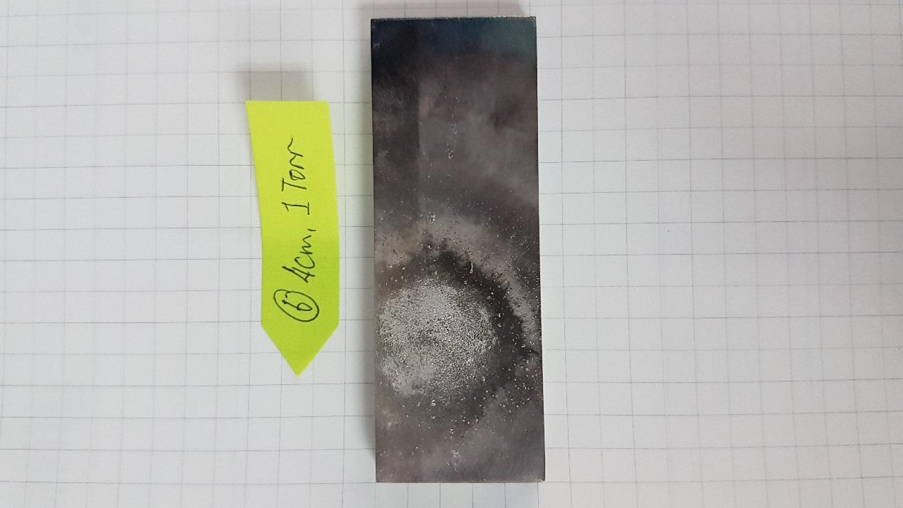

Figure 1. Example of the caption for the figure

Table 1. Example of the caption for the table

|  |  |  |  |
| --- | --- | --- | --- |
| Table 1 | Col 1 | Col 2 | Col 3 |
| 1 | Information A | Information B | Information C |
| 2 | A | 1.1 | 2.1 |
| 3 | B | 1.2 | 2.2 |
| 4 | C | 1.3 | 2.3 |
| 5 | D | 1.4 | 2.4 |
| 6 | E | 1.5 | 2.5 |

**Results and Discussion**

Results has to be tied to the methodology and objectives stated. Results should be stated in alignment with the sequence of the methodology. Discussion should be concise and related to the results. Novelty should be stated in discussion. A brief comparison with others’ research is highly recommended. Results and Discussion should be the main constitution of the paper.

One level of subsection is allowed for Results and Discussion.

**Conclusion**

Conclusion should be made to close the main content of the paper. Suggestions for future research can be added as a part of the conclusion but should not be the main agenda in this section.

**Acknowledgements**

Grant and fund providers should be acknowledged in this section (with grant number). Service providers such as institutes of research, universities, organizations, or research teams (without grant number) can be added as well. Personal individuals are not encouraged to be added here. The editorial board retains the right to remove any individuals added in this section.

Authors are encouraged to add the statement “There is no grant or funding bodies to be acknowledged for preparing this paper” if there are nothing to be acknowledged.

**References**

References should be stated in APA format, and should be arranged in alphabetical order. Abbreviations of journal names should be avoided. Please include the relevant DOIs for each reference (unless it is not available) as stating DOI mandatory for cross checking the references.

Example for journal:

Teo, S. C., & Wong, L. S. (2014). Whole cell-based biosensors for environmental heavy metals detection. *Annual Research & Review in Biology*, *4*(17), 2663-2674. <http://dx.doi.org/10.9734/ARRB/2014/9472>

Wong, L. S., Lee, Y. H., & Surif, S. (2013). Whole cell biosensor using Anabaena torulosa with optical transduction for environmental toxicity evaluation. *Journal of Sensors*, *2013*, ID 567272. <https://doi.org/10.1155/2013/567272>

Example for book:

Meriluoto, J., Spoof, L., & Codd, G. A. (Eds.). (2017). *Handbook of cyanobacterial monitoring and cyanotoxin analysis*. John Wiley & Sons. <https://doi.org/10.1002/9781119068761>

Example for conference paper:

Matta, S., Kumar, M. P., Adia, N., Madrahimov, S., & Bergbreiter, D. (2018). *Utilization of iron magnetic nanoparticles for the extraction of oil from aqueous environments*. In *Qatar Foundation Annual Research Conference Proceedings* (pp. EEPD360). <https://doi.org/10.5339/qfarc.2018.EEPD360>